REPORT ON DSchola Policy Workshop on MULTINCLUDE

The Policy workshop organized by Dschola about Multinclude was held online on November 11, 2020 from 14.30 to 16.30

The online workshop was attended by important local and national stakeholders: the Deputy Mayor of Education of the City of Turin – dr. Antonietta Di Martino, the Vice Rector of Education of the University of Turin – prof. Barbara Bruschi, the coordinator for the Inclusion of Regional branch of the Ministry of Education in Piemonte, prof. Paola Damiani. Also we had the participation of school principals, teachers from different grades (primary and secondary) from schools located in different regions of italy. We invited representatives of the good practices selected by the project, like Cafe Latte, Pedagogy of Parents, Calamaio, S4D and two important NGOs: SaveTheChildren and Maestri di Strada, that attended the meeting.
We had 27 participants.

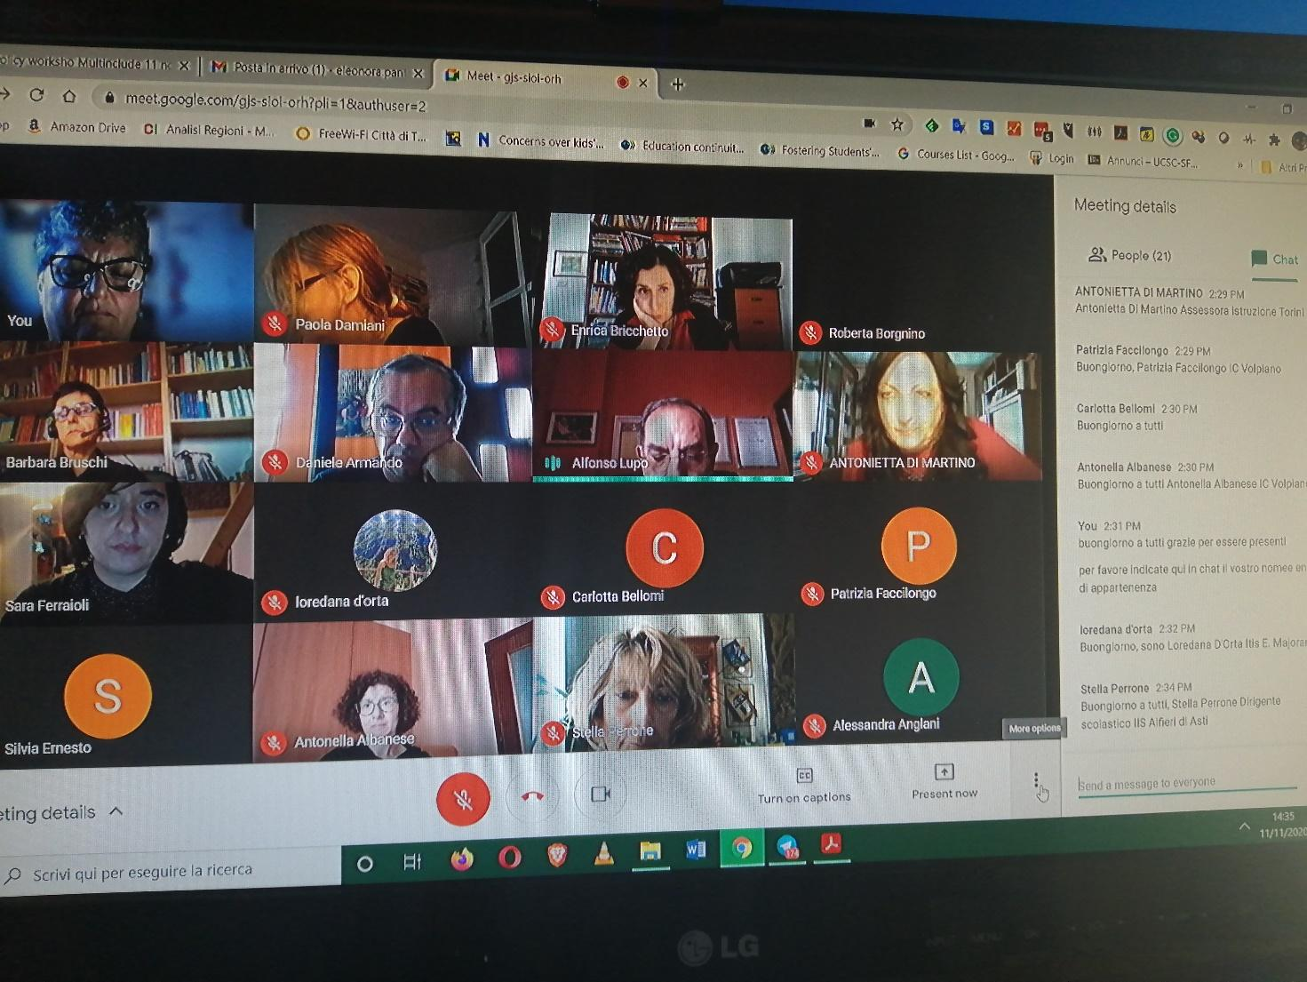

The Workshop was ideally divided into three parts: the presentation of the project and the inclusion matrix, the intervention of the Deputy Mayor about the policies for educational inclusion of the City of Turin and the discussion with representatives of the world of education also for subsequent actions.

Presentation of the Multinclude project

Prof. Alfonso Lupo, the President of DSchola Association introduced the works, presenting the Association mission, the agenda and the aim of the meeting that focused on inclusion issues. the Workshop was aimed to present the results of the Multinclude project with an in-depth examination of the Matrix for inclusion and discussing its possible impact on schools, through a conversation among the participants.

Prof. Enrica Bricchetto, from Dschola staff, described the activities carried out by the project, including the collection of good practices and the analysis and its theoretical references. Moreover, she presented the inclusion matrix with the description of the seven dimensions and four areas, in the multilingual offline version and in the interactive online version. She encouraged the possibility to subscribe to the MOOC (Paths for Inclusive Education) and the Learning community.

The inclusion policies of the City of Turin

Mrs Antonietta Di Martino, the Deputy Mayor, emphasized in her speech how inclusion can be understood in an extensive way as a right to health and she recalled UNESCO principles about the theme of inclusion.
Furthermore, she recalled the national legislation, emphasizing how local governments are responsible to provide services to support fragile students (with disabilities, migrant backgrounds, socio economic difficulties, etc.) like transportations, special cares, economic support etc). She continued explaining what has been achieved by the City of Turin on the topic of inclusion and presented the contribution of the City in two of the good practices already present in Multinclude, and precisely the School in Hospital and Try again Sam. Regarding Try Again SAM, the City continues in investing with its own resources and with the support of the banking foundation to fight early school leaving: the city reinforced this action during the first lockdown and the summer, also supporting the educators in the new approach required by the distance education.
Since it is now demonstrated the cruciality of the first years of life to determine school success and well-being, Di Martino suggested adapting the matrix also to be used in kindergarten.

The round table with the education experts
The debate started with a stimulus from prof. Lupo asked the participants, what are the preconditions and approaches that can facilitate inclusive education.
Prof. Barbara Bruschi, Vice Rector for Education in Torino University, responded by pointing out two crucial factors that are Culture and Politics, arguing that the Culture of inclusion is still missing and that Politics does not facilitate its application. It is therefore necessary to move to action with two concrete actions and she suggests Training and Research, taking into account the theory from the Pedagogy of Change that suggests that it is important to start from the bottom.
Prof. Paola Damiani, expert and researcher in the field of inclusion, shares the importance of the culture of inclusion and continues with a reflection on how broad the field of research is starting from terms like "Education" and "Inclusion", and how the relationship between education and education is not yet clear for everyone. Prof. Damiani considers a good reference the Objective 4 of the United Nations Agenda 2030 on Sustainable Development which deals with ensuring quality, fair and inclusive education for all. She also quotes the economist Stefano Zamagni (https://en.wikipedia.org/wiki/Stefano_Zamagni) who speaks about pedagogy in educational processes and addresses the issue of educational co-responsibility.
Prof. Stella Perrone, schools principals, focused her intervention on the role of the principal in the school that it is crucial for managing policy of inclusion, through the definition of measurable objectives and based on concrete actions. It is also important at an organizational level, the availability of resources as a staff that deals with inclusion, able to share the objectives and involve students in the process.
Going even more specifically into the objectives of the meeting, prof. Lupo makes another stimulus to the roundtable: how the Multinclude matrix can be an instrument of self-empowerment and how it can be promoted.
Prof Bruschi stressed the importance of the training aimed at the awareness of their rights and quoted the Charter of the Rights of the disabled, and the difference between rights and concessions.
Prof. Damiani insisted on the importance that the government supports extra-school activities and the evaluation and subsequent recognition. She also dwelled on the epistemological dimension of inclusion, stressing the importance of the process of self-analysis to change own practices and the need to contextualize and give continuity to actions in individual territories. Furthermore, she believes that the inclusion matrix is a useful tool made available to schools, to be used to complement other tools already available (in Italy school used an online tool called Self Evaluation Report - “RAV" – Rapporto di AutoValutazione” in Italian) for continuous improvement.
Prof. Perrone agrees on the importance of the RAV and she is interested in integrating the inclusion matrix as a tool of self evaluation. Regarding the inclusion matrix, after a real test in her school, for a future implementation she suggests to use a Likert scale instead of a simple YES, NO, I DON'T KNOW in the seven dimensions tab to provide the answers.
Dr. Sara Ferraioli of Maestri di Strada, joined the conversation illustrating the activities carried out by them in the Campania region and Prof. Fiorella Miotti starting from what has been done in her school about parent pedagogy, points out the importance of educational co-responsibility between schools and families.

Next actions and impact
Prof Lupo invited the participants to formulate a possible future path: we registered a shared request from continuing the discussion to deepen this topic and foster a collaboration among different actors.
Prof. Filomena Tramonte from I.C. di Voltri and researcher at the University of Genoa proposes the establishment of a permanent round table.
Prof. Bruschi of the University of Turin formulated the proposal to schedule a meeting in the University with students of education and future teachers.
The Association will take charge of following up the suggested actions.

